**10/05/2017**

**Steps for installing PMSES on a new machine, using Command Box**

**Note: It is VITAL that your location for the Commandbox settings NOT end up in a path with a space. So, since my document path contains “Don Bellenger”, I don’t put my .Commandbox into my document folder. I put the Command box settings into C:\COMMANDBOX. I install the actual box.exe into c:\programFiles\commandbox. That folder contains Commandbox.properties, which contains one line:**

**Commandbox_home=C:/CommandBox**

**Steps:**

Download and install Commandbox, in C:\Program Files\CommandBox, all by itself.

Install commandbox with Java included (assuming Java is not already there) from the web. Instructions are at <https://commandbox.ortusbooks.com/content/getting_started_guide.html>.

Make sure PATH points to C:\Program Files\CommandBox. You can edit environment variables by typing path in the windows search box, and following instructions.

If Commandbox is already installed, Issue the box command: upgrade, to get the latest Commandbox

Use ConEmu over Windows Powershell. Put ConEmu onto your start menu.

Make a Powershell profile using Sublime:

C:\Users\dbellenger\Documents\WindowsPowerShell\Microsoft.PowerShell_profile.ps1, containing

#These are directory alias commands

function cdCF2016 { cd "C:\projects\cbsites\CF2016" }

function go { cd "C:\projects\cbsites\ CF2016"

box }

In Powershell, "go" will start commandbox in the right place.

Copy coldbox directory from an existing coldbox directory, to C:\projects\cbsites\ CF2016. This is at the same level as pms-es will be.

Copy your entire software base (including .git) to the correct location, e.g. C:\projects\cbsites\CF2016\pms-es.

Use sublime to make C:\projects\cbsites\ CF2016\go.boxr, containing

server start cfengine=adobe@2016.0.04+302561 port=50016 name=cf2016 –force

This defines the CF version, and port for the application.

Make  C:\projects\cbsites\CF2016\ server-cf2016.json, containing

{

"app":{

"cfengine":"adobe@2016.0.04+302561"

},

"name":"cf2016",

"web":{

"http":{

"port":"50016"

}

},

"jvm":{

"args":"-Doracle.jdbc.J2EE13Compliant=true"

}

}

This make the characteristics of the driver to Oracle be correct, so the calendar will operate.  This is all using a named commandbox server: CF2016.

At the CommandBox>: prompt, run "recipe go.boxr" in the box environment, to bring up in Chrome a directory listing of C:\projects\cbsites\CF2016.

Be sure the data sources for pmsescb and filestorage are defined. Browse to

127.0.0.1:50016/CFIDE/administration/index.cfm and log in admin/commandbox.

You must define pmsescb and filestorage in there, to point to the Oracle database.

A better way to get the data sources is to use cfConfig in command box. See “CB cfconfig.docx”

Run pms-es with something like 127.0.0.1:50016/pms-es/?fwreinit=true (make a bookmark)

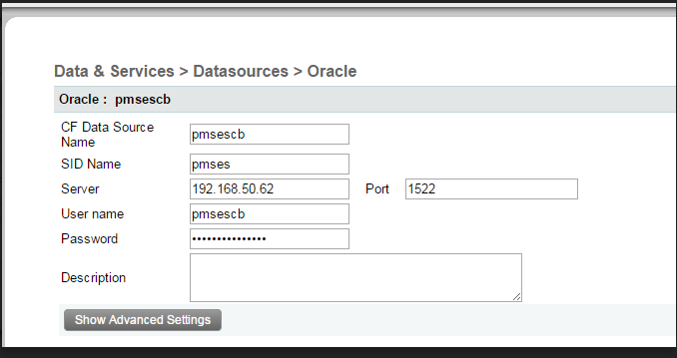

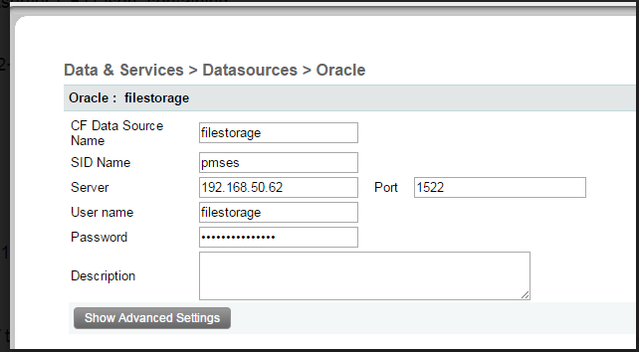

The link to start the application is 127.0.0.1:50016/pms-es/?fwreinit=true